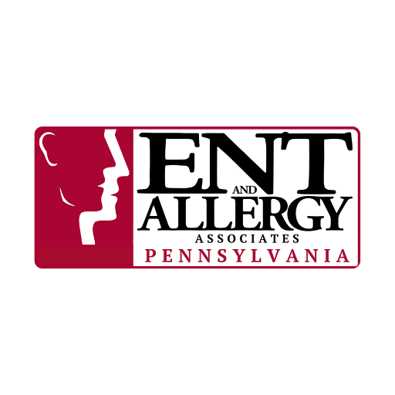

Use this checklist before any outdoor activity to keep everyone safe and comfortable:
✅ Printable Family Allergy Safety Checklist
☐ Daily allergy medications taken two weeks before the start of your allergy season
☐ Check the pollen forecast before heading out
☐ Rescue inhaler (if needed)
☐ Two epinephrine auto-injectors (if needed)
☐ Allergy “Go-Bag” with antihistamines, nasal sprays, eye drops and anti-itch cream
☐ Allergy-safe snacks and meals
☐ Sunscreen (hypoallergenic/mineral-based) and hats/sunglasses for sun protection
☐ Picnic blanket or tarp
☐ Insect repellent (as age-appropriate)

